3D Modelling; The theory and uses
Geometry
In this section I will be covering the different terms that are used to describe objects, in terms of their geometry.
Vertex
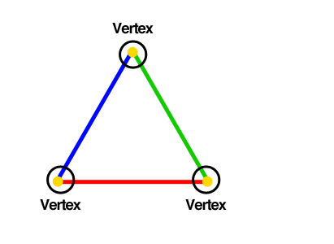
When talking about vertexes in 3D modelling, you are usually referring to the “points” at which two lines meet, or the corners. Vertexes are useful because they actually essentially give the shape its geometry, as without the vertexes there wouldn’t be a shape, because the lines wouldn’t have anywhere to connect up to. When vertexes are shown in 3ds max, they aren’t shown in the game, but are shown in the software because it useful to see them, as it then allows you to edit where those vertexes are.
Edge
As you can probably imagine by the name, and edge in 3D modelling is the line that joins two vertexes, therefore creating the shape. The edges are shown when an object is selected, to help the person that is modelling to see the exact shape of what they are making, and also to be able to edit the edges it is useful to be able to actually see them. When in a game or video, the edges aren’t shown.
Face
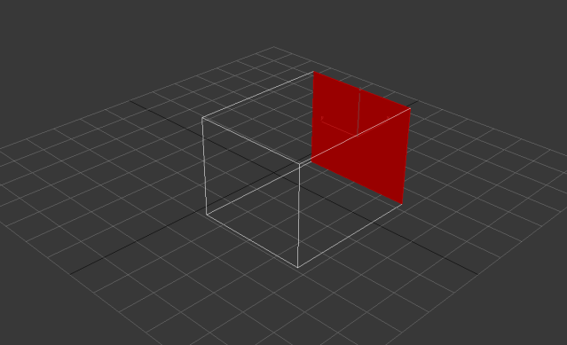
By looking at this picture it is clear to see that a face in 3ds max is any place where there are 3 or more vertexes connected, in this case the back facing face is highlighted. When using the face tool, you are able to edit the location of the face, and can even delete certain faces.

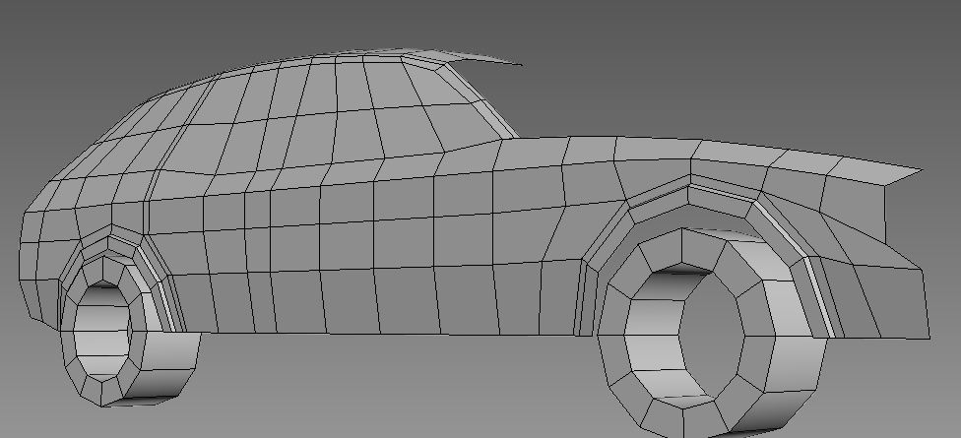
Polygon
When using 3d software such as 3ds max, it is important to remember that anything you create will be made out of a polygon, as shown in the picture. Polygons are what help create curvature in objects and basically anything that you want. A polygon is usually either a quad or a tri, which means either a square or a triangle, although when using quads they are often broken up in half to make tris. In a game, you will need to try to keep the poly count low, as if there are too many polygons on a certain object the framerate will be highly reduced compared to if the PC only had to render fewer polygons.
Quad
A quad, as briefly described above, is an invisible square on a 3d object which makes up that objects geometry, also known as a polygon. The more quads you have on a certain object, the more detailed that object will be.
Tri
Also briefly spoken about above, the tri is simply half of a quad. The tri is a quad broken into two. The tri is useful when doing very detailed objects such as spheres. This is because compared to a quad; the tri has overall more geometry and can be bent in more ways, making smoother shapes. The disadvantage of using a tri is the fact that it could result in a lower framerate, as you essentially have double the amount of polygons than if you were to use quads.

3D Primitives
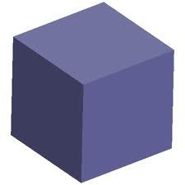
Box
The box is the king of all shapes, almost used in every single scene ever created in the history of 3d modelling. The box can be manipulated in every way possible, and is used to start creation of more complicated objects.

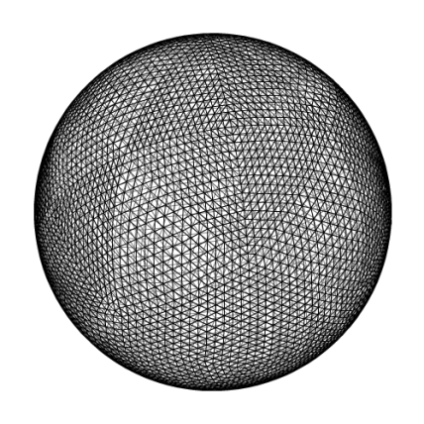
Sphere
The sphere in 3ds max is usually composed of lots of quads in a perfect spherical shape. The spheres in 3ds max have great customizability such as changing the smoothness and number of quads. Here is an example of a very high poly, but very smooth sphere created with 3ds max.
Cylinder
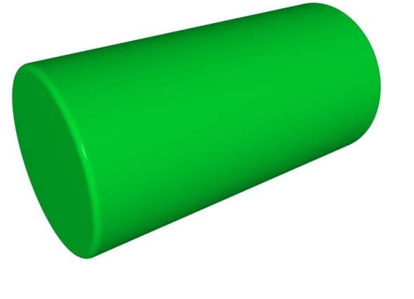
When you use the cylinder tool in 3ds max, you get to customize how wide the base is and how tall they are. The cylinder primitive is very useful, as it means that you don’t have to create one yourself.

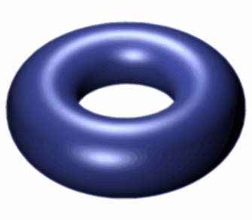
Torus
The torus primitive is a tool that allows the user to create a donut shape with customizable thickness and size. The torus tool also lets you change the number of “sides” or polygons that the shape will have, therefore either creating a very smooth or very rough doughnut.

Cone
Cones are also easily created in 3d software by simply using the tool, which gives options like size and height. The cone tool is useful for putting spikes on things, which might have been have a hard task using just boxes for example.

Plane
The plane is a very useful object when using 3ds max. This is because as it first starts out, the shape is simply a very flat square. When creating a terrain or anything big and needs a mountainous or natural looking area, a big plane can be used to create the terrain. This is because the plane can be made to have lots of polys on it, and the edges of that poly can be raised or lowered to create terrain.

Where models can be used
Models created using 3d software can be used in a huge amount of places. One of those places is of course the gaming industry. The models that are used in the games don’t have to be highly detailed on order to look acceptable, and this because the majority of the models are usually just walked past, and not observed for what they actually are. Another place that the models can be used is the product manufacturing industry. The models are useful there because it is useful to be able to see what the product would look like without actually having to manufacture it. The 3d model is useful for that as they can be very accurate, and be observed in 3d. This will also save the company money. 3d models can also be used and exported directly to a 3d printer, which can create a small but touchable copy of what you are trying to model.

  - Bibliography
Image 1 - http://www.andrespagella.com/img/articles/understanding-css-custom-filters/fig1.png
Image 2 - http://i40.tinypic.com/2je4j5s.png
Image 3 - http://4.bp.blogspot.com/--_B18xAWuWM/ULNra6OUqcI/AAAAAAAABFQ/Kk4BPqc1lyE/s1600/Poly02.JPG
Image 4 - http://www.nicoptere.net/dump/refine.png
Image 5 - http://previewcf.turbosquid.com/Preview/2014/07/09__18_43_46/download.jpg467e375b-4bba-416a-8104-35967953fcf4Large.jpg
Image 6 - http://area.autodesk.com/th.gen/?4/365xf-4k4y3-z436i-w3pr8:640x640.jpg
Image 7 - http://area.autodesk.com/th.gen/?4/365xf-4k4y3-z436i-w3pr8:640x640.jp
Image 8 - http://upload.wikimedia.org/wikipedia/commons/thumb/f/f7/Torus2.svg/400px-Torus2.svg.png
Image 9 -

